**ASSIGNMENT:** PYTHON PROGRAMMING FOR GUI DEVELOPMENT

**Name**: D. Hari Charan

**Register number:** 192311319

**Department:** Computer Science Engineering

**Date of Submission:** 26/08/2024

**Problem 4:** Real-Time COVID-19 Statics Tracker

**Scenario:**

A Real-Time COVID-19 Statistics Tracker provides up-to-date global and local data on cases, deaths, recoveries, and vaccination progress, often with interactive features and visualizations. It helps users monitor trends, healthcare capacity, and policy changes in real-time.

**Tasks:**

1. Gather data from various sources such as health organizations, government agencies, and hospitals.
2. Compile and synchronize data from different regions and sources to provide a unified view.
3. Continuously update the tracker with the latest information to reflect current statistics and trends.
4. Present data through charts, graphs, and maps for easy interpretation and analysis.
5. Identify and display trends over time, including case surges and declines.

**Deliverables:**

1. An interactive, user-friendly interface displaying current global, national, and local COVID-19 statistics, including cases, deaths, recoveries, and vaccination rates.
2. Data Visualizations: Graphs, charts, and maps that illustrate trends, distributions, and comparisons over time and across different regions.
3. Trend Analysis Reports: Summaries and analyses of trends, such as case spikes, recovery rates, and hospitalization trends.
4. Alert System: Notifications and alerts for significant changes or updates in data, such as new outbreaks or policy changes.
5. Historical Data Archive: Access to past data and trends for historical analysis and comparison.

**Solution:** Real-Time COVID-19 statistics tracker

**1. Flow Diagram:-**

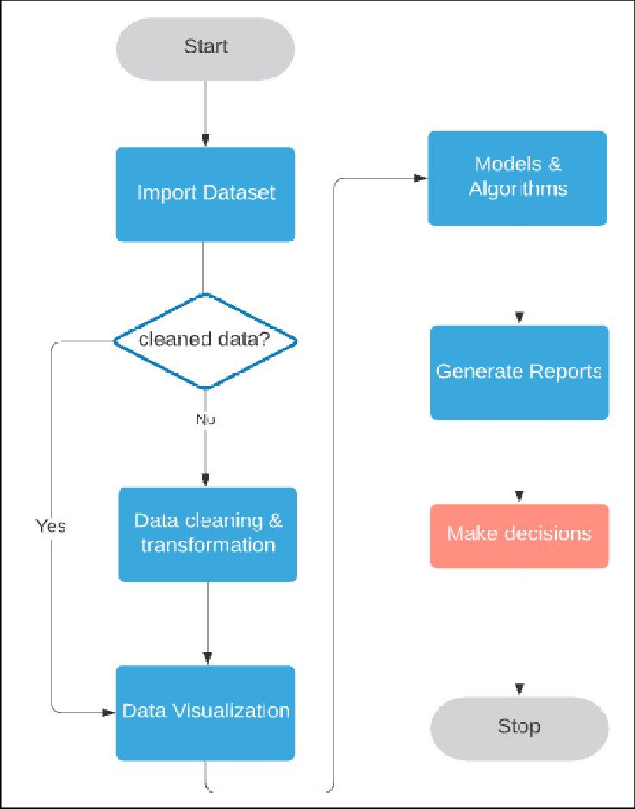

**2.** **Implementation:-**

import requests

def fetch_covid_statistics():

url = "https://disease.sh/v3/covid-19/all"

response = requests.get(url)

if response.status_code == 200:

data = response.json()

print(f"Total Cases: {data['cases']}")

print(f"Total Deaths: {data['deaths']}")

print(f"Total Recovered: {data['recovered']}")

else:

print("Failed to retrieve data")

if __name__ == "__main__":

fetch_covid_statistics()

**3.Display covid 19 statistics information:**

**Enter city:** Kurnool

**Total cases:** 200

**Total deaths:**50

**Total recover:**150

**4.user input:**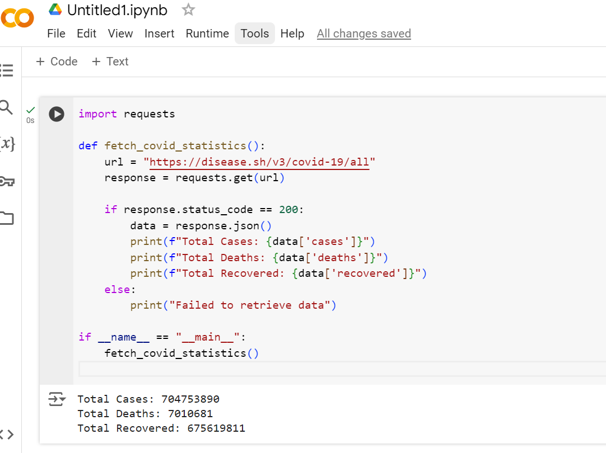

**5.Documentation:**

**1. Features**

The COVID-19 Statistics Tracker offers a range of functionalities to keep users informed about the pandemic's status:

* **Real-Time Data Updates:** Provides current statistics on COVID-19 cases, recoveries, and deaths globally and locally.
* **Interactive Charts:** Visualize trends and historical data with charts and graphs.
* **Customizable Filters:** Filter statistics by date, geographic region, and data type.
* **Vaccination Statistics:** Track and view vaccination rates and progress.
* **Alerts and Notifications:** Set up notifications for significant changes in statistics.

**2. Data Sources**

The tracker aggregates and updates data from the following sources:

* **Johns Hopkins University (JHU):** Provides global data on case numbers, recoveries, and deaths.
* **World Health Organization (WHO):** Offers global and regional data and vaccination statistics.
* **Local Health Departments:** Supplies detailed statistics for specific regions and cities.
* **Government and NGO Reports:** Contributes additional data and contextual insights.